**CS 487 DATA SECURITY**

**HOP01B – Installing Visual Studio Code**

12/7/2020 Developed by Mary Oh

X/X/2020 Reviewed by XXXXX

Center for Cybersecurity Innovation (C4CYI) @City University of Seattle (CityU)

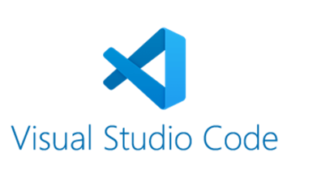

**Before You Start**

* Version numbers may not match with the most current version at the time of writing. If given the option to choose between stable release (long-term support) or most recent, please choose the stable release rather than beta-testing version.
* This tutorial targets Windows users.
* There might be subtle discrepancies along the steps. Please use your best judgement while going through this cookbook style tutorial to complete each step.
* For your working directory, use your course number. This tutorial may use a different course number as an example.
* The directory path shown in screenshots may be different from yours.
* If you are not sure what to do or confused with any steps:
  + Consult the resources listed below.
  + If you cannot solve the problem after a few tries, ask a TA for help.

**Learning Outcomes**

* Learn how to install Microsoft Visual Studio Code

**Resources**

* Visual Studio Code - <https://code.visualstudio.com/>

For this course, you will be learning Azure and Infrastructure as Code (IaC). Before starting with Azure, you will need Visual Studio Code. Visual Studio Code will help make Azure development easier, such as getting started quickly, easier deployment, remote debugging, and exploring visually.

**Installing Visual Studio Code**

1. Download - <https://code.visualstudio.com/download>
2. Once the download is complete, open the .exe file.
3. Accept the agreement and click on next.

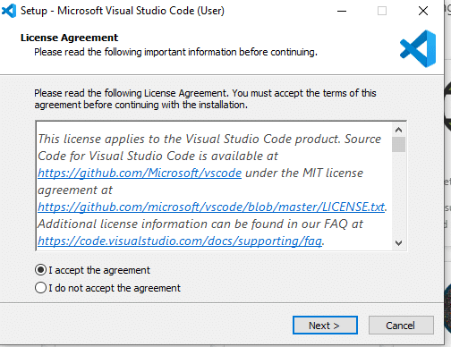

1. Create a desktop icon so that it can be accessed from the desktop and click on next.

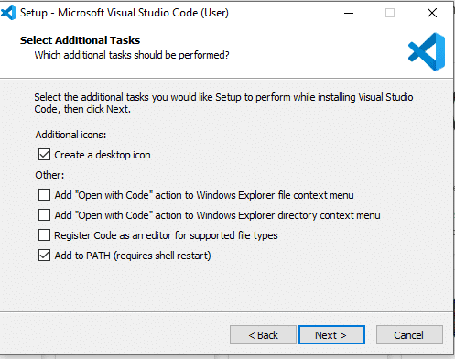

1. Click on install button.

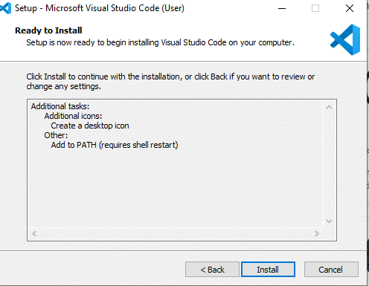

1. After the installation completes, click on the finish button.

